COMHAIRLE CHONTAE LONGFOIRT

Longford County Council

Corporate Affairs,
Aras an Chontae,
Please note Meeting will be held LONGFOIRT.
in the Council Chamber, Great Water Street.

4th November 2015.

Chuig: Gach Ball don Chomhairle.

A Chomhairleoir,

You are requested to attend the Statutory Local Authority Budget Meeting of Longford County Council to be held in the Council Chamber, Aras an Chontae, Great Water Street, Longford, on Wednesday, 18th November 2015 at
4.00 p.m. to transact business as set out on the agenda hereunder.

Mise le meas,
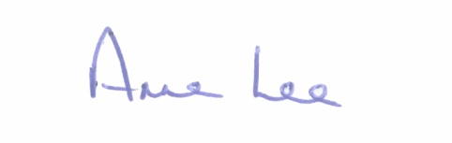

________________
Anne Lee,
Meetings Administrator.

1. Consideration of Draft Budget 2016 - Draft Budget enclosed

2. Consideration of Report on Capital Programme - Report enclosed.

:::::::::::::::::::::::::::::::

